GAINESVILLE-ALACHUA COUNTY REGIONAL AIRPORT AUTHORITY
Thursday, May 22, 2025 at 4:00 p.m.
Airline Terminal Board Room
Monthly Meeting Highlights

Call To Order By the Chair: Chair Craig Carter called the meeting to order at 4:00 p.m.

Invocation: Mr. Carter delivered an invocation.

Pledge of Allegiance: Mr. Carter led the Pledge of Allegiance.

GACRAA General Counsel: Mr. Blake Fugate was present.

Roll Call
Authority Members Present: Craig Carter, Adrian Hayes-Santos, Fred Posner, Brandi Renton, Staci Sims and Kinnon Thomas were present.
Teresa Callen, Brian Crawford and Wes Maul were absent.
Ex-officio member Eric Godet, Sr. was present. City of Gainesville liaison, Forrest Eddleton, was present.

Determination of a Quorum: A quorum was present at roll call.

Approval of Meeting Highlights of April 24, 2025
Mr. Thomas moved to approve the GACRAA meeting highlights of April 24, 2025. Mr. Posner seconded the motion. Mr. Hayes-Santos recommended amending the minutes to reflect that his comment thanking staff for staying late to assist overnight stranded World Masters passengers was on behalf of the Alachua County Commission. The amendment was accepted by the Board and motion passed.

Citizens Input – Non-agenda Items: None

Airport Authority Input – Non-agenda Items: None

Adoption of Agenda
Mr. Thomas moved to adopt the agenda. Ms. Sims seconded the motion. Motion passed.

Airport Business

Information Items
Mr. Penksa presented photos illustrating the status of several ongoing construction projects.

Terminal Phase IV – Construct Baggage Handling System (BHS) and Airline Ticket Office (ATO) Expansion/Renovations – Phase I
Mr. Penksa reported that the installed screening fabric color is incorrect and will be replaced in mid-June. He indicated that irrigation, landscaping and sodding has been installed and miscellaneous paving is complete.

Tailwind Vending Concession Addition and Renovations
Mr. Penksa reported that a new sewer line to the grease interceptor was constructed and all landscaping and irrigation in this construction area has been restored. He reported that all underfloor plumbing has been installed and the contractor is now working on installing electrical service.

Airport Parking Garage / Multi-Modal Facility
Mr. Penksa reported that work continues on the covered walkway foundation, building joint sealing and electrical work. He stated that all vehicle entrance and exit lanes and the electrical service required for the revenue control system have been installed. He stated that the bus canopy has been framed. He noted that all interior concrete has been poured.

Taxiway A Rehabilitation and Reconfiguration
Mr. Penksa reported Work has begun on the new underdrain at T/W A and D. The contractor has two crews working day shift and night shift to complete the work ASAP. Daily night-time runway closures are in effect for construction within the Runway Safety Area. Work on completing the 42” concrete pipe drainage connection will occur after the underdrain work is complete. He stated that FAA has approved the change order for the underdrain work and will determine which funding program will be applied for this work.

North Corporate Hangar – Bldg. GA-37
Mr. Penksa reported that construction of the hangar is complete. A final walk-through was held with the contractor and the tenant on 5/14/2025. A few minor work items were identified which will be completed. All punch list work is expected to be complete by 6/1/2025 at which time the building will be turned over to the tenant.

Turo, Inc. License Agreement for Peer-to-Peer Car Sharing Service
Mr. Penksa recalled that the Board approved the execution of a License Agreement with Turo, Inc. GACRAA had offered the multi-modal facility for a concession fee of 12% of gross, or in a surface parking lot for a 10% concession fee. Mr. Penksa reported that Turo has requested that one (1) space (and accompanying signage) be allocated for Turo use at the garage pick-up/drop-off lane.

Mr. Thomas moved to amend the License Agreement to allocate 1 dedicated space for Turo at the new garage. Mr. Hayes-Santos seconded the motion.

Airport Master Plan Update and Stormwater Master Plan
Mr. Penksa reported that the project website has been created, and staff comments were returned to the consultant. He noted that when the website is live, it will include a survey form for tenants and the general public.

Fuel Farm Expansion
Mr. Penksa reported that final site plan revisions have been sent to the City and staff is awaiting receipt of the site plan permit. Fabrication of the unit continues.

GACRAA as a Voting Member of the Metropolitan Transportation Planning Organization
Mr. Penksa reported that staff is awaiting the final agreement for execution. He indicated that the county and the FDOT are working out final edits to the MTPO Joint Agreement. The edits pertain to the procedure for choosing the rural representative. A final document will be circulated for signature and will be placed on the Consent Agenda. A renewed Intergovernmental Review and Public Transportation Coordination Joint Participation Agreement must also be executed with the state. A draft will be circulated for review and signature.

Book Vending Machine Proposal
Mr. Penksa reported that the Vending Agreement has been executed. Staff is awaiting delivery of the machine and books. He noted that The Lynx Bookstore has had one person apply for an Airport ID Badge to service the machine in the secured gate area.
Air Traffic Volume Report and Load Factor
Mr. Penksa reviewed the Air Traffic Volume, Fuel Flowage and Load Factor reports for April, 2025. He reported that he and Ms. Porter will attend ACI-NA’s JumpStart® Air Service Development Conference in Indianapolis in June. He stated that they have meetings scheduled with GNV’s legacy carriers and will focus the discussion on frequency and aircraft size.

Finance Report
Mr. Lyons provided the Finance Report for the month ending April 30, 2025 in the agenda packet.

Revenue | April 2025 Actuals | April 2025 Budget | Variance Over / (Under)
Total Operating Revenue | $876,414.16 | $841,618.03 | $34,796.13
Expenses | April 2025 Actuals | April 2025 Budget | Over / (Under)
Total Expenses | $600,475.87 | $633,816.08 | ($33,340.21)
Income (Loss) Before Depreciation and Interest | $275,938.29 | $207,801.95 | $68,136.34
Less: Interest Expense | $0.00 | $0.00 | $0.00
Income (Loss) Before Depreciation | $275,938.29 | $207,801.95 | $68,136.34
Industrial Park Land Sales | $0.00 | $0.00 | $0.00
Income (Loss) | $275,938.29 | $207,801.95 | $68,136.34

Mr. Thomas moved to accept the Finance Report. Mr. Hayes-Santos seconded the motion. Motion passed.

Finance, Audit and Operations Committee Report
Ms. Sims reported that the Finance, Audit and Operations Committee met on May 22 at 2:30 p.m. and received the FY2023-2024 Audit Report from Purvis Gray Co. Copies of the FY2023-2024 Audit Report were distributed to the Board.

Purvis Gray Audit Partner Barbara Boyd presented the FY2023-2024 Audit Report. She reported that Purvis Gray is providing an unmodified “clean” opinion of on the financial statements meaning that the opinion is the highest level of assurance that the auditing firm can provide to GACRAA for reliance on the report. Ms. Boyd reported that there were no internal control deficiencies to disclose to the Board.

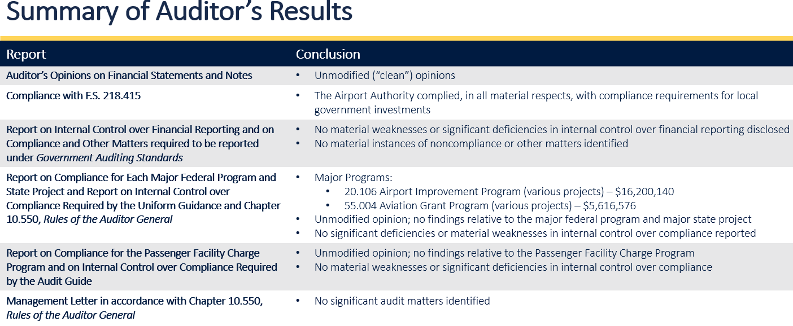

Mr. Thomas moved to accept the FY2023-2024 Financial Audit as presented by Purvis Gray Co. Ms. Sims seconded the motion. Motion passed.

FAA AIP Grant # 3-12-0028-058-2025 Application and Acceptance – Design Only Commercial Apron Expansion West – Resolution 25-010
Mr. Penksa recalled that the Board previously selected a consultant to design an approximate 11,800 sq. yd, expansion of the west side of the Commercial Apron. He stated that the FAA grant application in the amount of $622,617.00 represents ninety-five (95%) of the FAA-eligible costs of the design of the expansion.

Mr. Thomas moved to adopt Resolution 25-010 approving the application and acceptance of anticipated FAA AIP Grant # 3-12-0028-058-2025 Ms. Sims seconded the motion. A roll-call vote followed: Ms. Renton – aye, Ms. Sims – aye, Mr. Thomas – aye, Mr. Hayes-Santos – aye, Mr. Posner – aye, and Mr. Carter – aye. Motion passed 6-0.

RFP # 25-002 Rental Car Concession Agreements – Resolution 25-011
Mr. Penksa reported that four proposals were received in response to RFP #25-002 for rental car concessions to operate from the five rental car counters and office suites and to utilize the consolidated quick turnaround facility and ready-return parking lots. He noted that all four incumbent companies, representing seven brands, responded to the RFP. He briefly reviewed the anticipated revenues proposed by the rental car operators and noted that the combined total Minimum Annual Guarantee is $1,354,845 more than the current contract over the initial 5-year term of the Agreement.

Mr. Thomas moved to adopt Resolution 25-011 approving the award of rental car concession agreements to the following four respondents to RFP 25-002: 1) Avis Rent A Car System, Inc. (Avis/Budget), 2) Enterprise Leasing Company of Florida, LLC (National/Alamo), 3) Enterprise Leasing Company of Florida, LLC (Enterprise), and 4) The Hertz Corporation (Hertz/Dollar).
Mr. Hayes-Santos seconded the motion. A roll-call vote followed: Ms. Sims – aye, Mr. Thomas – aye, Mr. Hayes-Santos – aye, Mr. Posner – aye, Ms. Renton – aye, and Mr. Carter – aye. Motion passed 6-0.

RFB #25-004 Terminal Outbound Baggage Handling System – Phase II Contract Award – Resolution 25-012
Mr. Penksa reported that one bid was received in response to RFB #25-004 for the construction of an expansion of the existing outbound handling system. He stated that the bid award, in the amount of $4,797,575 for the Base Bid and Bid Alternates 1 and 2, is contingent on FAA award concurrence and FAA approval of requested PFC and FAA grant funding. He stated that FAA has already approved BIL-ATP discretionary funding in the amount of $3,000,000.00 for the project. He reviewed the funding opportunities for the balance of the proposed bid amount as described in the resolution.

Mr. Thomas moved to adopt Resolution 25-012 approving a contract award to Scherer Construction of North Florida, LLC for construction of an expansion of the existing outbound Baggage Handling System (RFB# 25-004) contingent on FAA award concurrence , FAA approval of requested PFC and FAA grant funding and legal counsel review and approval. Ms. Sims seconded the motion. A roll-call vote followed: Mr. Thomas – aye, Mr. Hayes-Santos – aye, Mr. Posner – aye, Ms. Renton – aye, Ms. Sims – aye, and Mr. Carter – aye. Motion passed 6-0.

Tenant Report
UAC General Manager Karen Collins reported that athletic charters are winding down. She indicated that UAC is considering spending $100K to $200K on office renovations.

Airport Authority Input – Mr. Eddleton reported that the City Commission is interested in Economic Development and is interested in airport development as well as other efforts within the City.

Mr. Penksa displayed a slide showing United Airlines aircraft at the Consortia Aerospace ramp. Consortia is installing Starlink Wi-Fi on 300 ERJ190 aircraft.

Mr. Penksa reported that City Commissioner Ed Book transmitted an email expressing his thanks to Craig Carter and the Board members for their efforts in promoting airport development.

Mr. Carter thanked Eric Godet and Forrest Eddleton for their participation in GACRAA meetings and assistance in advancing airport projects.

Mr. Godet reported that visitors from a Gainesville Sister City arrived at GNV last week.

Adjournment
At 4:46 p.m., there being no further business, Mr. Thomas moved to adjourn the meeting. Mr. Hayes-Santos seconded the motion. The meeting was adjourned.

GACRAA Monthly Meeting

_ _______________________________________ _____________
Chair Date

________________________________________ _____________
Vice-Chair Date

